**Café Encanto Product Inventory System: Desktop Based Application**

*Lea Mae A. Batchain*

Bachelor of Science in Information Technology

Polytechnic University of the Philippines – Santa Rosa Campus

[leamaeabatchain@iskolarngbayan.pup.edu.ph](mailto:leamaeabatchain@iskolarngbayan.pup.edu.ph)

*Aira Lei C. Carpena*

Bachelor of Science in Information Technology

Polytechnic University of the Philippines – Santa Rosa Campus

[airaleiccarpena@iskolarngbayan.pup.edu.ph](mailto:airaleiccarpena@iskolarngbayan.pup.edu.ph)

*Rizza S. Constantino*

Bachelor of Science in Information Technology

Polytechnic University of the Philippines – Santa Rosa Campus

[rizzasconstantino@iskolarngbayan.pup.edu.ph](mailto:rizzasconstantino@iskolarngbayan.pup.edu.ph)

*Jerald D. Ganacias*

Bachelor of Science in Information Technology

Polytechnic University of the Philippines – Santa Rosa Campus

[jeralddganacias@iskolarngbayan.pup.edu.ph](mailto:jeralddganacias@iskolarngbayan.pup.edu.ph)

*Lyka Mae Gambot*

Bachelor of Science in Information Technology

Polytechnic University of the Philippines – Santa Rosa Campus

[lykamaergambot@iskolarngbayan.pup.edu.ph](mailto:lykamaergambot@iskolarngbayan.pup.edu.ph)

*Patrick Jeremie Maniaul*

Bachelor of Science in Information Technology

Polytechnic University of the Philippines – Santa Rosa Campus

[patrickjeremiemaniaul@iskolarngbayan.pup.edu.ph](mailto:patrickjeremiemaniaul@iskolarngbayan.pup.edu.ph)

*Sean Daniel Marc S. Mendoza*

Bachelor of Science in Information Technology

Polytechnic University of the Philippines – Santa Rosa Campus

[seandanielmarcsmendoza@iskolarngbayan.pup.edu.ph](mailto:seandanielmarcsmendoza@iskolarngbayan.pup.edu.ph)

**PREFACE**

As a part of the new curriculum and in order to enhance practical knowledge in programming, we are required to make an application to serve as our final exam. This final project is entitled “Café Encanto Inventory System.” The basic objective behind doing this project is to make a reliable and efficient system for managing the café's inventory. In this project, we have included various functions for viewing, storing, updating, and deleting products in the inventory. Doing this inventory system helps us improve our skills in programming. We did some research to help us make the application. Through this report, we learn about the importance of teamwork and the role of devotion towards the work.

**INTRODUCTION**

According to Mwamba and Yangailo (2024), inventory management is essential to the successful operation of every business. Managing inventory efficiently and effectively will allow the organization to avoid too many investments. It enables management to make easier and more precise decisions. It will also help to increase the value of many businesses' current assets (Team, n.d.). Effective inventory management ensures that businesses have the correct products in the right quantities, decreasing the possibility of stockouts and ensuring that customers get what they need when they need it (Inventory, n.d.). Café Encanto Inventory System is the administration of products stored in a database. It includes the activities of adding, viewing, updating, deleting products. The main purpose of this system is to make it easy to control and monitor stock levels accurately, which helps the café lower the possibility of overstocking or stockouts of products. As members of Generation Z, we have noticed that a lot of students these days study and unwind at local coffee shops. Students prefer drinking coffee while studying, so we selected a café as the company for our inventory system. Our group chose this system because it will help Café Encanto to reduce waste, keep an ideal inventory, and increase their overall production. It is not only a tool for inventory control systems. This system may help the owner to complete inventory-related duties quickly and effectively, which keeps the café running smoothly. Cafe Encanto employs six staff, including its owner. The staff comprises two baristas, two cashiers, an owner and another administrator. The cafe serves approximately 250 customers every day. The inventory system is a crucial part of the café business plan, which aims to increase business performance, cut expenses, and provide customers with an amazing experience.

**PLATFORM**

**Operating System:** Windows 11

**Technologies Use:**

**Front End:** Java Swing, JDK 22

**Language:** Java

**Back End:** MySQL

**Software Requirements:**

Minimum:

Operating System: Windows 10 or later (including Windows 11).

* Java Development Kit (JDK): JDK 21 (Java SE 21). Ensure proper configuration within Visual Studio for Java development.
* Integrated Development Environment (IDE): Visual Studio with Java extension.
* Database Server: XAMPP (Apache, MySQL, PHP).
* Web Server: Apache HTTP Server (part of XAMPP).
* SQL: SQL for database management and queries.

Recommended:

* Operating System: Windows 11 (latest update recommended).
* Java Development Kit (JDK): JDK 21 (Java SE 21).
* Integrated Development Environment (IDE): Visual Studio with Java extension (latest version).
* Database Server: XAMPP (Apache, MySQL, PHP).
* Web Server: Apache HTTP Server (part of XAMPP).
* SQL: SQL for database management and queries.

**Hardware Requirements:**

Minimum:

* Processor: 1 GHz or faster processor.
* RAM: 2 GB RAM.
* Storage: At least 500 MB of available disk space.
* Display: Minimum resolution of 1024x768 pixels.

Recommended:

* Processor: Multi-core processor (Intel i5 or equivalent) or better.
* RAM: 4 GB RAM or higher.
* Storage: SSD with at least 1 GB of available disk space for development tools and projects.
* Display: Full HD resolution (1920x1080 pixels) or higher.

**Software Requirement Specification:**

1. **Introduction**

**1.1 Purpose**

The purpose of this document is to define the essential requirements for developing a Java GUI Café Inventory Management System that includes CRUD functionalities. This system aims to enhance the existing Café Encanto Inventory System by facilitating efficient management and monitoring of stock levels. By providing a user-friendly interface and robust features, the system aims to increase operational efficiency and customer satisfaction within the café environment. The primary goal is to simplify inventory handling for users, thereby improving overall café management processes and ensuring timely and accurate stock control.

**1.2 Scope**

* Café Encanto Inventory System manages inventory items such as supplies and menu items.
* This system will allow the owner to perform CRUD operations on these items while ensuring that inventory data is up-to-date and very accurate.
* This system has different features such as search product, search account, add account and delete account.
* This system will support the monitoring and reporting of inventory levels, which will help prevent overstocking or stockouts. Also, it will help the cafe make good decisions about inventory purchases and usage.
* System has print and export functionalities to provide soft and hard copies of up-to-date inventory reports and is intended to smoothly integrate into the café's everyday operations, delivering extensive inventory management features that will support Café Encanto’s overall business goals.

**1.3 Definitions, Acronyms, and Abbreviations - Technology Overview (Java, My SQL, Apache, xampp etc).**

IMS - Inventory Management System

DBMS - Database Management System

IDE - Integrated Development Environment

SQL - Structured Query Language

HTTP - Hypertext Transfer Protocol

OS - Operating System

GB - Gigabyte

GHz - Gigahertz

SSD - Solid-State Drive

HD - High Definition

RAM - Random Access Memory

PHP (Hypertext Preprocessor: A general-purpose scripting language often used for web development.

GUI (Graphical User Interface): A user-friendly interface with visual elements like buttons, menus, and text boxes for interacting with the system. In this project, Java Swing is used to create the GUI.

JDK (Java Development Kit): A software package containing tools and libraries required for developing Java applications.

Java: A high-level, object-oriented programming language.

MySQL: An open-source relational database management system used to store and manage inventory data.

XAMPP: Allows developers to test their code locally on their own computers.

Apache: An open-source cross-platform web server.

CRUD: Create, Read, Update, Delete - Fundamental data manipulation operations used in software systems, especially for managing data in a database (relevant for product management in this project).

**2. Over-all Project Description**

**2.1 Project/product Perspective**

This is about developing a simple tool for managing stock control in a café, and it’s called the “Café Encanto Inventory System.” The main purpose is to ensure that the café owner can trace their supplies and ingredients with ease and update them on a day-to-day basis. This system will be part of the everyday activities of the café, resulting in effective inventory management.

**2.2 Project/product Functions**

Inventory Management/CRUD operations:

* Create/add Product: Allows the owner to Create or add new products to the inventory, including details such as product name, description, price, and category.
* Read/view: Users can view existing inventory items. This may display details like current stock levels.
* Update Product: Enables users to modify existing product details.
* Delete Product: Permits users to remove products from the inventory.

Stock Management:

* Update Stock: Facilitates updating the stock quantities for each product, ensuring accurate inventory levels.

Reporting:

* Inventory Reports: Allow users to generate reports on various aspects of the inventory. This could include overall stock summaries, usage trends for specific items, or reports on low-stock or out-of-stock situations.

User Management:

Log In:

* User Authentication: Allow the owner to securely log in the system.
* Verify Password: System will verify whether or not the inputted username or password is correct or incorrect. It should display an error message if the inputted information is incorrect.
* Access Control: Ensures that only authenticated owner can access the system.

Log Out:

* Session Termination: Provides a secure way for users to log out of the system.

Search Management:

* Search Product: Allows the owner to search for products within the inventory using various criteria (e.g., product id, category).
* Search Account Info: Enables owner to search for account information, including user details and access levels.

Additional Functions:

Account Management:

* Add Account: Allows the owner to create new user accounts, assigning appropriate access levels.
* Delete Account: Permits the owner to remove existing user accounts from the system.

Main Menu Function:

* Navigation: Provides a central interface from which the owner can navigate to various system functionalities such as product management, stock management, search, and account management.

**2.3 User Classes and Characteristics**

The users of the proposed system will be those who are owning/ administering and have relation or working by the Cafe Encanto Inventory System since it can be applied in their day to day business transactions. The users who have the right to use the system will need some practice on how to manipulate the system in order to implement the system.

Users are required to have a background in using computers to handle product information and inventory.

User Classes and Characteristics

Owner/Admin

* Interact with the application
* Able to access/login to their account using their username and password provided
* Able to monitor the available supply
* Able to modifying, editing, adding, and deleting data in the system
* Able to log out from their account

**2.4 Operating Environment**

The system must be operated within the computer. The Cafe Encanto Inventory System is intended to work on Windows 11 operating systems.

To run the application smoothly, the hardware requirements are not high because the system only needs a 1GHz processor, 2 GB RAM, a minimum of 500 MB free disk space, and screen resolution of at least 1024x768 pixels.

Normally a database management system (DBMS) is used to store data and it is usually stored in a server where it will be used for managing data such as accessing, delete, update, and store new data to the database. In this IMS, database management and queries are done through MySQL. Further this application uses XAMPP as a web server consisting of Apache HTTP Server, MySQL, and PHP. By employing current technologies and assuring that it fits into commonly utilized platforms it provides a reliable and user-friendly interface.

**2.5 Constraints**

The Cafe Encanto Inventory System will be built utilizing a Java GUI framework, such as Swing or JavaFX, to provide interconnection with Windows, macOS, and Linux operating systems. The system will use XAMPP to run MySQL for database administration, which will require a JAR file (e.g.,'mysql-connector-java') to connect the Java application to the MySQL database. An Integrated Development Environment (IDE) such as IntelliJ IDEA, Eclipse, or NetBeans is required to develop, debug, and build the program, with the project set up to generate an executable JAR file for easy distribution and running.

The system will have a verification panel with user login and authentication, role-based access control to limit access to specific functionalities, and verification processes for essential tasks like adding or deleting inventory items. The user interface must be intuitive and responsive, including inventory management features such as search, filtering, and sorting. Robust error handling is required to manage database connectivity issues, invalid inputs, and other unexpected mistakes. Furthermore, the system must be thoroughly examined, including unit tests, integration tests, and user acceptance tests, to verify reliability and usability.

**2.6 Use case diagram/model**

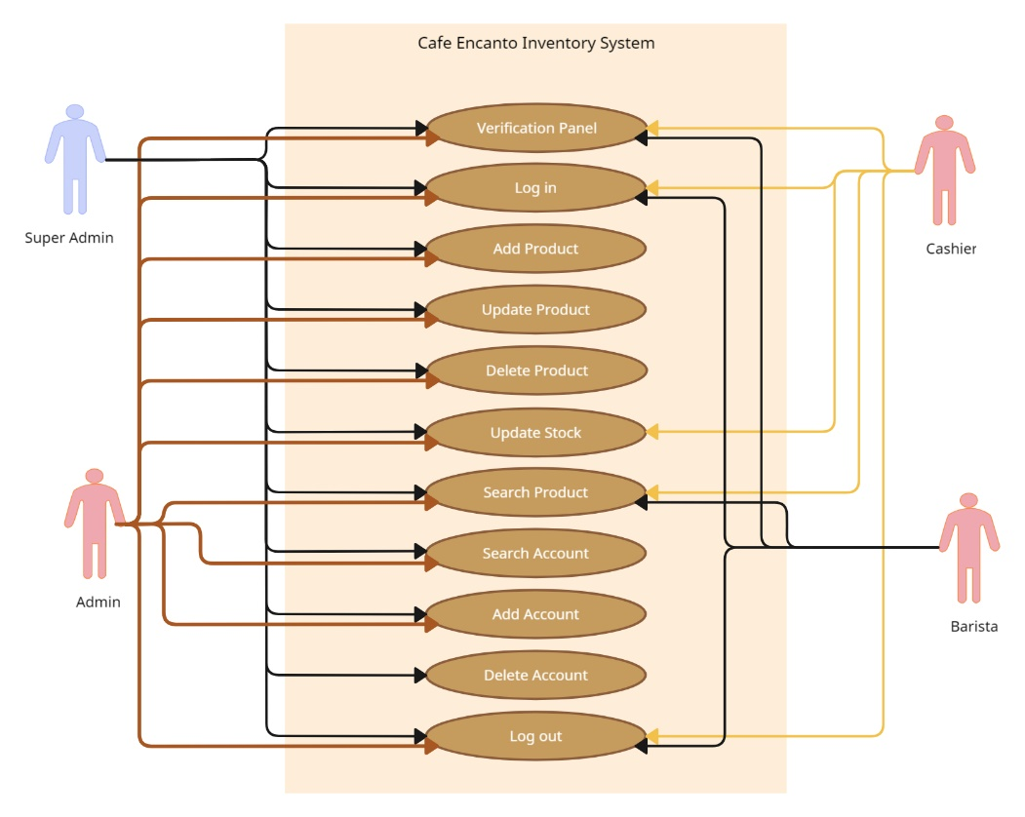

* 1. **System Architecture**

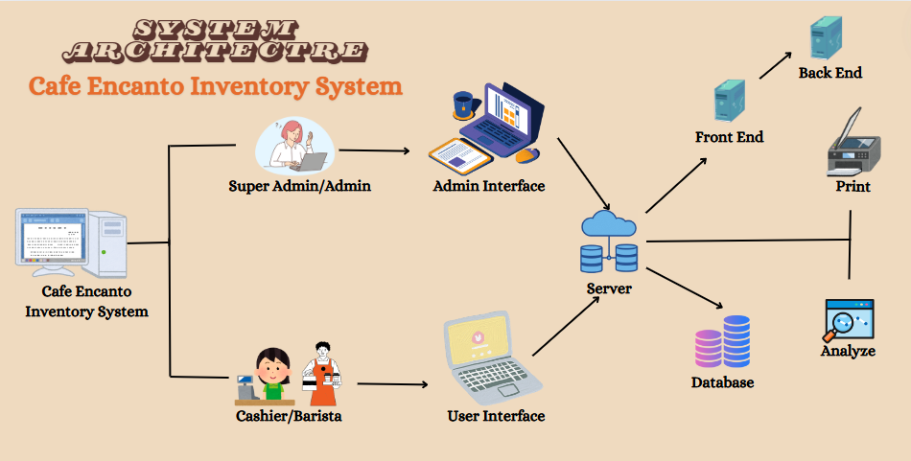

**3. Data Design**

* 1. **Entity Relationship Diagram**

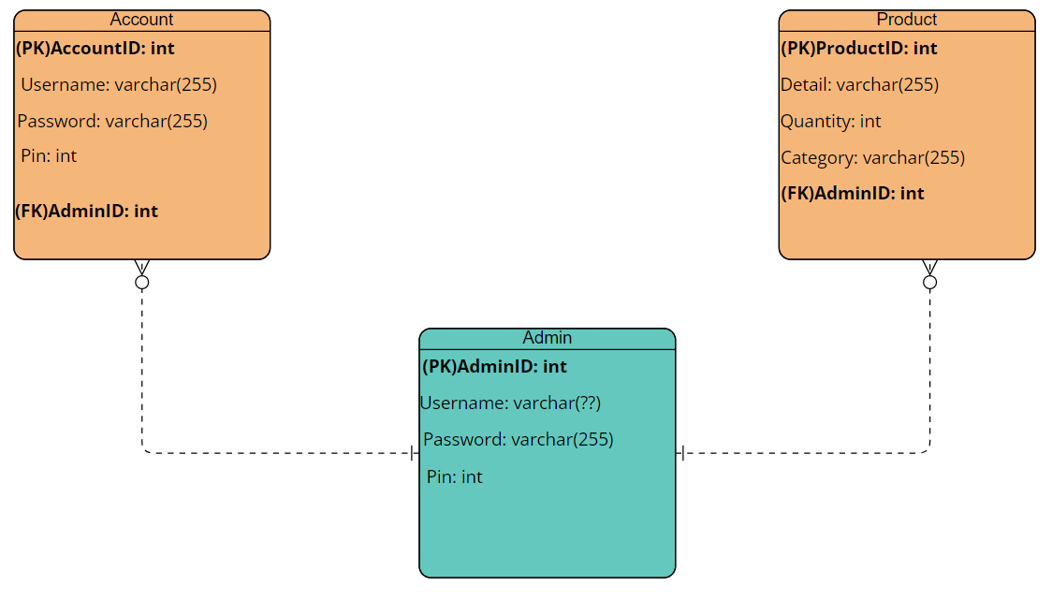

In the final Cafe Encanto Inventory System implementation, Users and Stock tables are designed to be separated. This has the added benefit of decoupling user authentication information from inventory data, leading to an overall modular and more secure system. There is no explicit association between the Users and Stock tables in this version, but that's appropriate for basic inventory management constraints. If a relationship were to get established these tables allow for future possibilities of the enhancement. These improvements are out of the scope of this final system, and they serve no purpose in its current operation.

**4.** **Functional Design Description**

**4.1  Activity Diagram**

**Super Admin Activity Diagram Admin Activity Diagram**

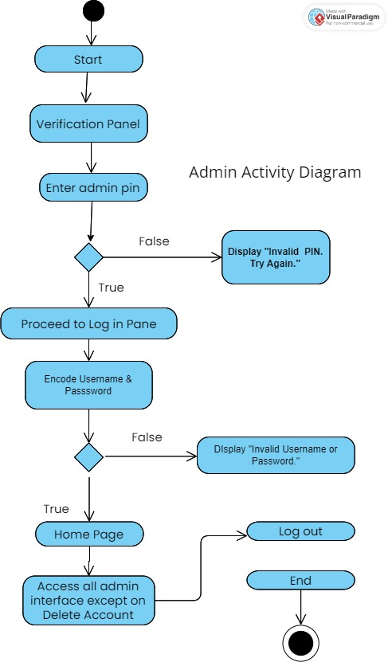



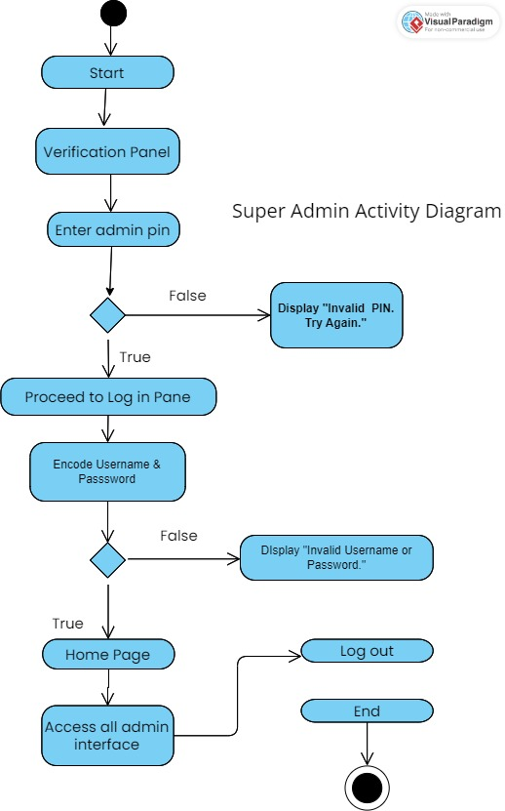



**Cashier Activity Diagram Barista Activity Diagram**

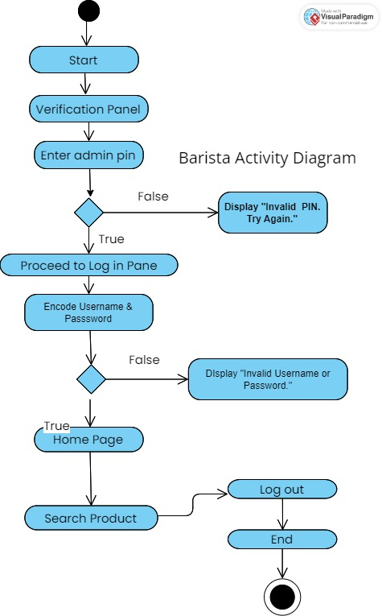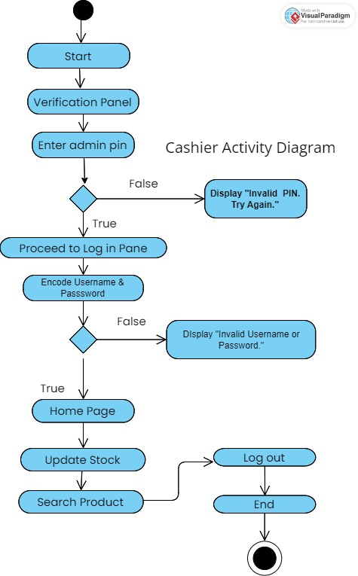



**5. System Walkthrough -Screen Record of GUI Modules**

**https://drive.google.com/file/d/1N9AqVMqQQP6EzT_Om3VCaNKJAvrLKhv2/view?usp=sharing**

**6. Source Code**

[**https://github.com/PJM012/CAFE-ENCANTO-SOURCE-CODE.git**](https://github.com/PJM012/CAFE-ENCANTO-SOURCE-CODE.git)

**7. Conclusion**

Café Encanto Inventory System assertion indicates an absolute breakthrough on the terrain of inventory management in the café environment. As emphasized by Mwamba and Yangailo (2024), efficient inventory management is a key factor for the optimal performance of any business. The instrument guarantees that no miscalculation is made in the supplying or warehousing of any product thus reducing errors. It does this through the receipt, display, update, and delete of the item and hence forth decreases the probability of too much or no stock, that supports better business conditions through more efficient and satisfied customers.

The front end was designed with Java Swing while MySQL was used for the back end. The tool's functionality to generate accurate inventory reports enables strategic decision-making which in turn permits the café to be more efficient in its supply chain, have zero waste, and increase the overall productivity. Also, the system runs perfectly on Windows 11 and employs other software like XAMPP and Apache which ensure it is fully functional in the desired environment.

Café Encanto would implement this inventory management system to bring to its system a higher level of accuracy in inventory tracking and control leading to more efficacy and decreasing operational costs. The system, apart from managing stocks, also acts as a tool to support the café's efforts involved in rendering customer satisfaction. This study establishes the crucial inventory management performance of a business and as a solution offers the operational resources to Café Encanto.

**8. Recommendations in System**

* Addition of ciritical level warning to products with low stocks
* Add roles for better functionality, such as Super Admin-Owner, Admin-Manager, POS/Cashier, and Kitchen-Barista.
* Delete a product and update a product functionality must be deleted and will be replaced by the delete and edit button in the stocks page for less hassle.
* The record of the process could be automatic or manual.

**9. References**

* Team, P. W. (n.d.). *THE IMPACT OF INVENTORY MANAGEMENT AND CONTROL ON PERFORMANCE | ProjectClue*. https://www.projectclue.com/management/project-topics-materials-for-undergraduate-students/the-impact-of-inventory-management-and-control-on-performance#:~:text=This%20is%20so%20because%20managing,current%20asset%20of%20many%20companies.
* Inventory, C. F. (n.d.). *The impact of inventory management on customer satisfaction*. Cash Flow Inventory. https://cashflowinventory.com/blog/impact-of-inventory-management-on-customer-satisfaction/#:~:text=Effective%20inventory%20management%20helps%20ensure,essential%20factor%20in%20customer%20satisfaction.
* Mwamba, E., & Yangailo, T. (2024). The impact of inventory management on the performance of an organization. *Revista CientíFica Profundidad Construyendo Futuro/Revista Científica Profundidad Construyendo Futuro*, *20*(20), 77–85. https://doi.org/10.22463/24221783.4184
* BoostMyTool. (2021, October 5). Connect to MySQL Database from Visual Studio Code and Run SQL Queries using SQLTools Extension [Video]. YouTube. https://www.youtube.com/watch?v=wzdCpJY6Y4c
* Eye on Tech. (2020, May 3). What is Inventory Management? The Basics of Inventory Management [Video]. YouTube. https://www.youtube.com/watch?v=rIJwIrGRYAk
* NetSuite. (2023, March 3). Restaurant Inventory Management: Benefits & Best Practices [Video]. YouTube. https://www.youtube.com/watch?v=jbfIm8s-15c
* BoostMyTool. (2021, December 22). Create your First Java Frame using Visual Studio Code | Create Java GUI Forms using VS Code [Video]. YouTube. https://www.youtube.com/watch?v=5G2XM1nlX5Q
* Code With Arjun. (2021, September 21). Run Java program in Visual Studio Code | VsCode extension for java programming in VsCode [Video]. YouTube. https://www.youtube.com/watch?v=kt3wUPIDkx4
* BoostMyTool. (2021, September 28). How to setup JavaFX in Visual Studio Code 2021 [Video]. YouTube. https://www.youtube.com/watch?v=AubJaosfI-0
* BoostMyTool. (2021, December 29). JAVA - Create Login Form Using MySQL and Visual Studio Code [Video]. YouTube.
* BoostMyTool. (2021, December 29). JAVA - Create Login Form Using MySQL and Visual Studio Code [Video]. YouTube. https://www.youtube.com/watch?v=kQxsaQgL4B8
* Geeky Script. (2022, December 31). How to Install XAMPP 8.2.0 Server on Windows 10/11 [2023 Update] Run PHP Program | Complete guide [Video]. YouTube. https://www.youtube.com/watch?v=VCHXCusltqI
* Coding with Sudhir. (2022, May 30). Java and MySQL - how to insert update delete and search data [ with source code ] [Video]. YouTube. https://www.youtube.com/watch?v=IO2_1RwARp8
* Google. (n.d.). coffee images. Google search. https://www.google.com/search?client=ms-android-transsion&sca_esv=ffcfe78bb05bd262&sca_upv=1&sxsrf=ADLYWIJrF1B5pkRHHMnddoS-ELP7ctUqlg%3A1720807866062&q=coffee%2Bdesigns&udm=2&fbs=AEQNm0DPvcmG_nCbmwtBO9j6YBzM68ZanC7g01Skprhw5JoufVCiMv-hxC44jt6JduRQysBab-bgQXjPraaWFXMvOy8Kr1OAG3K-aj3De4zf3-LxKtkBtWaSCp743evHzhY6J0rIQUCXki65vOxhV0cGJtj0S1dF8YREnKrWtJctBkTv8-bs83YpB7p3IMTdYvjisDEty1xSxeLS4B_TKFXUiCrenmEMcA&sa=X&sqi=2&ved=2ahUKEwjwgdXsjKKHAxUkmFYBHQ81CVAQtKgLegQIRxAB&biw=980&bih=1818&dpr=3
* Exporting jar file in VS Code. (n.d.). Stack Overflow. https://stackoverflow.com/questions/51596602/exporting-jar-file-in-vs-code
* Greekman. (2016, April 21). Creating exe files for Java Apps using Launch4j. Javatidbits. https://javatidbits.wordpress.com/2016/04/21/creating-exe-files-for-java-apps-using-launch4j/
* Link all libraries into the executable (actually: make a deploy folder). (2016, February 10). Qt Forum. https://forum.qt.io/topic/63927/link-all-libraries-into-the-executable-actually-make-a-deploy-folder
* Mike Møller Nielsen. (2020, January 14). Java String Format [Video]. YouTube. https://www.youtube.com/watch?v=IzYCzegyaH0
* GSoft Knowledge. (2016, February 26). how to get Login username and password from sql database (SOLVED)- java tutorial #7 [Video]. YouTube. https://www.youtube.com/watch?v=_i63HeLWgpg
* Code With Arjun. (2021, July 11). Connect Java with Mysql Database | Java JDBC | Java Database connectivity | JDBC MySql | ArjunCodes [Video]. YouTube. https://www.youtube.com/watch?v=AHFBPxWebFQ